Legaspi, Rumil

STAT 521

Prof. Millie

9/15/20

LAB 1 Outputs

#1.

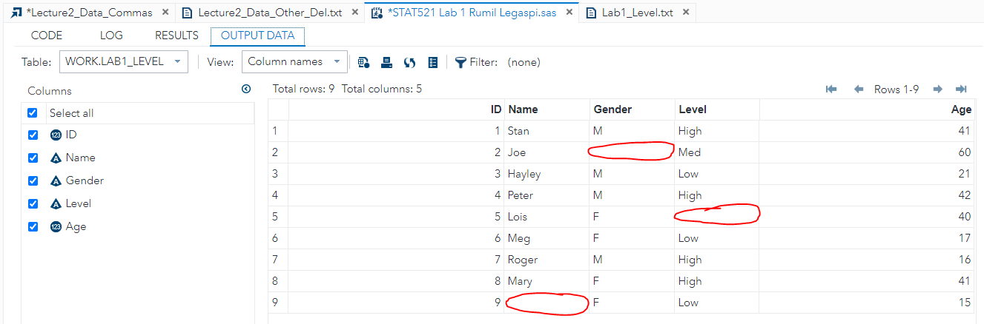

#2.

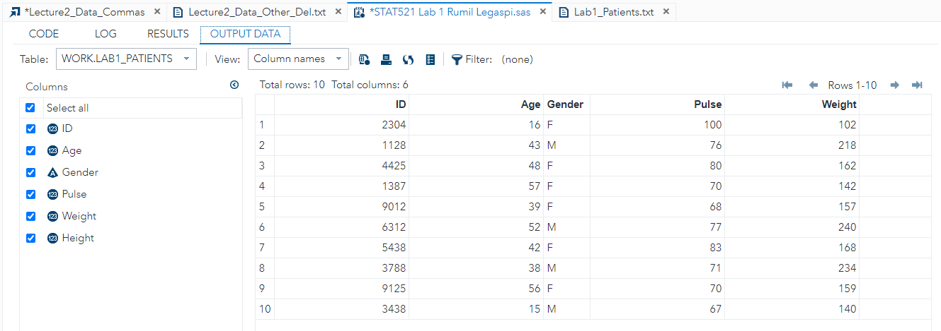

#3.

